**Project 4: Hosting static website using S3 bucket**

**S3 bucket**

**Steps:**

**1. Go to search bar and type s3. Click on s3.**

**2. In S3 dashboard, go to general purpose buckets and click on create**

**bucket button.**

**3. In general configuration, select bucket type as general purpose and give**

**name as anusha04.**

**4. Click on create bucket button. Your bucket is created.**

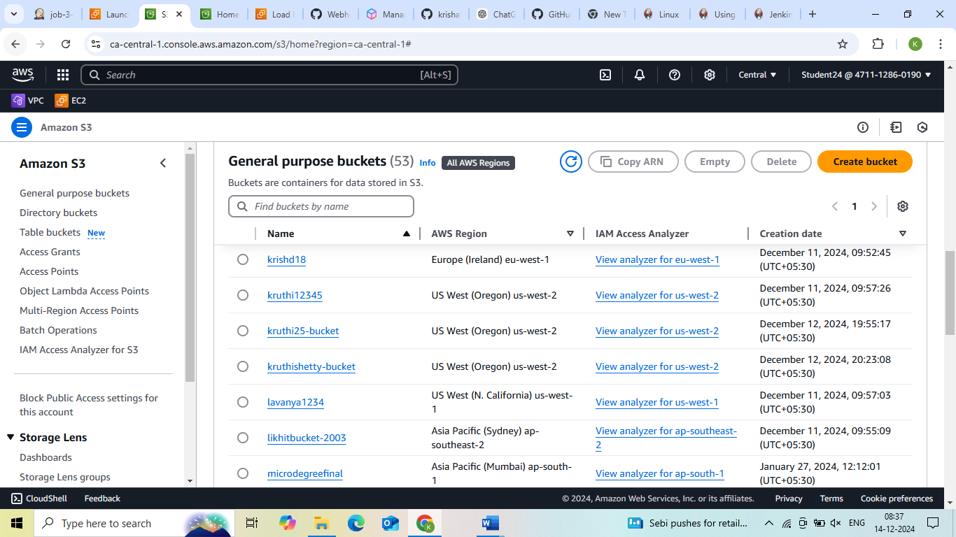

**Uploading a file:**

**Steps:**

**1. Click on created bucket.**

**2. Bucket window gets opened and click on upload button.**

**3. In upload window, select files and folders and Click on add files and**

**select the file you want to add.**

**4. Then click on upload. Your file is uploaded.**

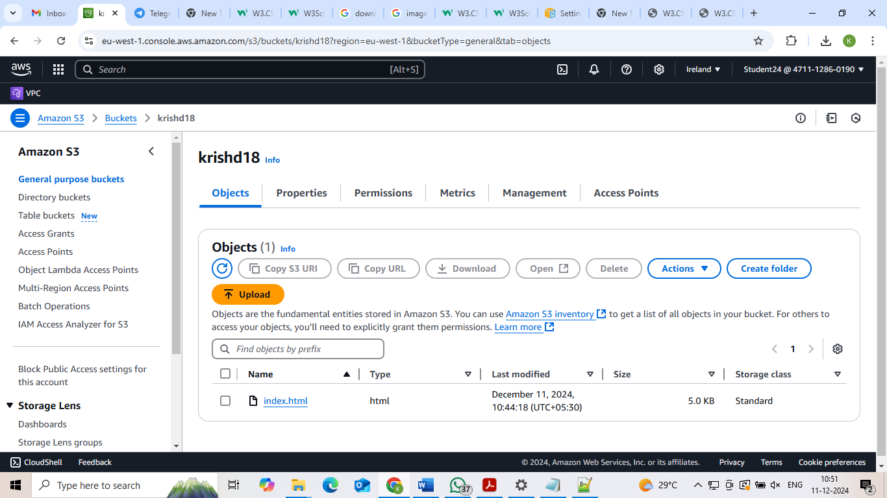

**Static website hosting:**

**Steps:**

1. **Select the properties, go to static website hosting and click on edit.**
2. **Give index document name as file name that is dailyping.html and click on save changes button.**

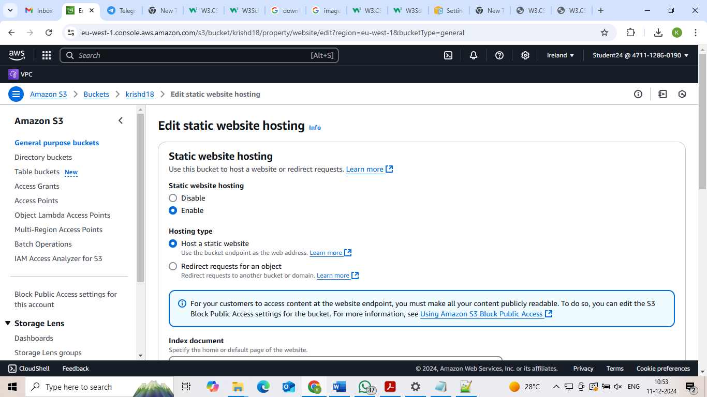

**Bucket setting:**

**Steps:**

1. **Go to permission, select block public access and click on edit.**
2. **Under block public access (bucket setting), uncheck the block all public access and click on save changes button.**

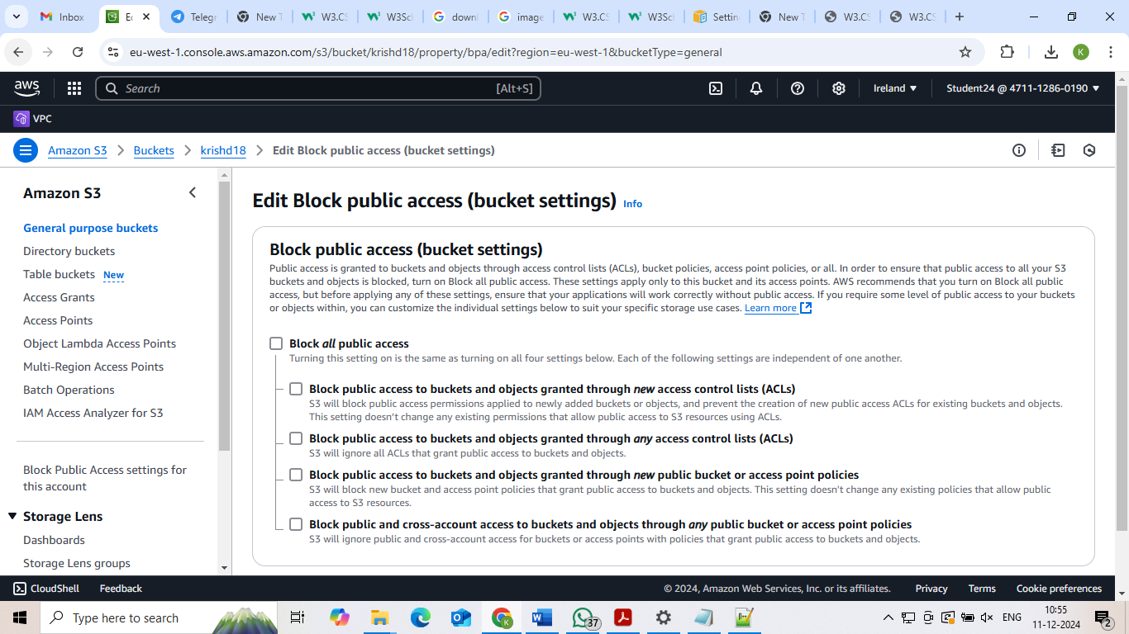

**Setting permission for website access and add bucket policy:**

**Steps:**

1. **Go to google browser and type bucket policy for static website.**
2. **You will get setting permission for website access and click on it.**
3. **You will get add a bucket policy and copy the code from the editor.**

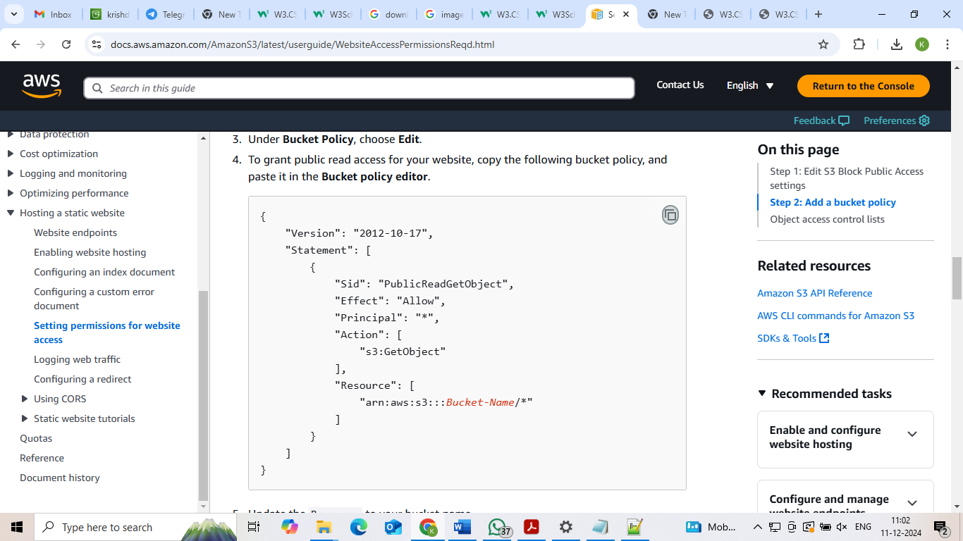

**Bucket policy:**

**Steps:**

1. **In permission, select bucket policy and click on edit.**
2. **Paste the code copied from the editor and change the ‘Bucket-Name’ as krishal18 (created bucket name).**

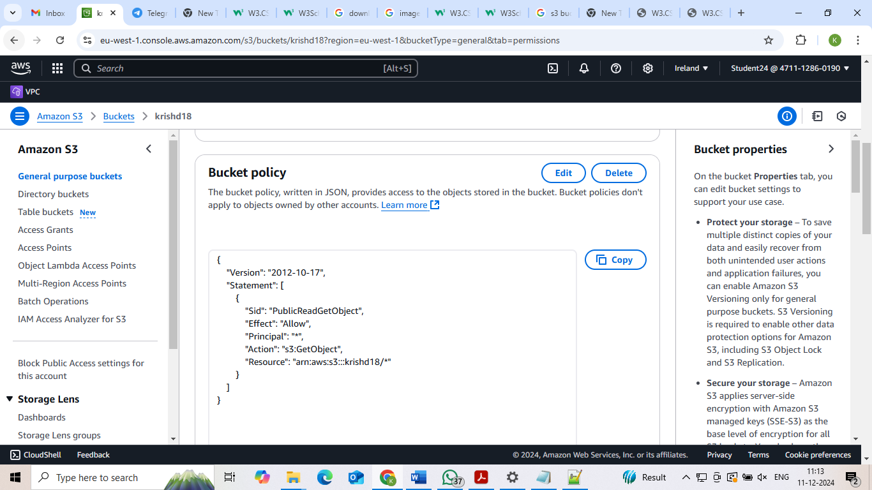

**Static website hosting url:**

**Steps:**

1. **In properties, under static website hosting, copy the bucket website endpoint url and paste it on google browser.**

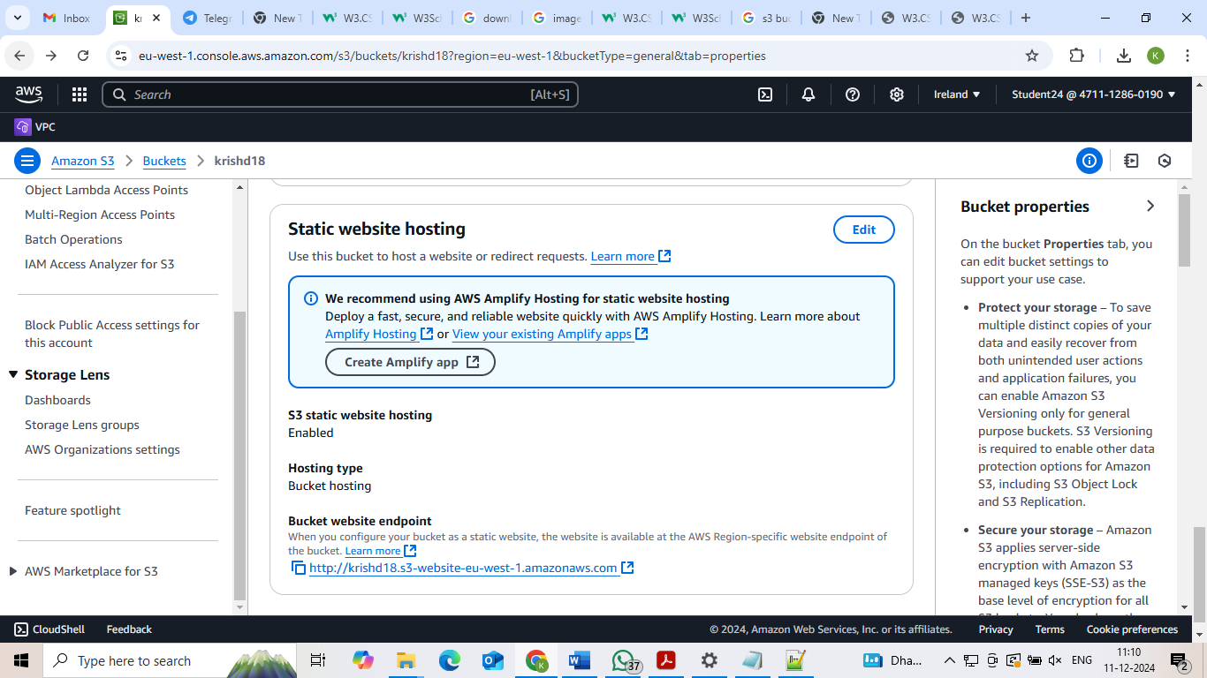

**Final Result**

